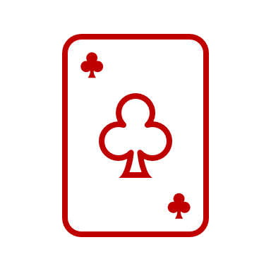******Make11**

**Testing Summary**

The testing techniques employed in my program are as follows.

***Junit Testing***

Three java classes make use of the JUnit testing. (make11, Highscore, RoundCount)

**Make11Test** class includes Junit testing for dealing initial cards and making sure it returns an array of five, which we will print to the user in the game. Functionality of the high scores table was being tested by inserting a new high score and expecting the value we passed into it. Testing to get the lowest score allows the user to make comparisons on whether their score should be put on the high score table.

**testReplacingCards()** test checks if two arrays are similar after we swap out a card, in which we assertFalse to complete the test. This functionality is utilised throughout the program to swap the users chosen card after they have made 11.

Additionally, edge case testing for invalid inputs were being tested where we input an invalid choice to check for invalid input handling, a while loop was used to correct the invalid input.

**HighscoreTest and RoundCountTest** both test the same functionalities which play a crucial role in keeping track of the users progress throughout the game. Functionality of the **increment()** method and the getter method **getScore()** has been tested by expecting specific values after a certain amount of increments.

***Test Code***

**Make11Test** class includes test code for printing out the 5 cards to the user which will be used throughout the course of the game.

**DeckTest** class contains test code to check that cards are being successfully being removed from the deck, in the example we print fifty random cards then print out the remaining deck, where we expect two cards to be left.

**CardTest** class we test out the functionality of making 11 with two predefined cards, we test the getter methods **getRankValue()** to make comparisons.

***Observation / Edge Case Testing***

Key functionalities of the make11 game is being tested additionally with edge cases and invalid inputs. Face card prompts only shows up when a face card is detected.

|  |  |  |  |
| --- | --- | --- | --- |
| Functionality | Expected Outcome | Result | Screenshots |
| Deal Cards | User is dealt five cards and allows them to pick option A-E | Pass |  |
| Deal Computer Card | Computers card is dealt and printed on screen | Pass |  |
| User picks an option | Chosen card’s rank is compared with computers card’s rank and chosen card is swapped | Pass |  |
| Face Card is detected in the deck while user makes 11 | Prompts user to enter option A-E to swap out face card only when detected | Pass |  |
| Invalid option (F-Z, 0-9 etc.) | While loop runs until a valid option A-E is chosen | Pass |  |
| Same suit | No point is awarded, round incremented, card is replaced and game continues | Pass |  |
| User scores higher than lowest highscore | User qualifies for highscore table and is prompted to enter their name | Pass |  |
| View replay | User selects yes when prompted to view replay | Pass |  |